Worship on the Lawn

WELCOME AND ANNOUNCEMENTS

PRELUDE

CONFESSION AND FORGIVENESS
P Blessed be the holy Trinity, ☩ one God,
who looks upon us in compassion,
forgives our sin, and heals our lives.
C Amen.
P Let us confess our sin in the presence of God and of one another.
(silence is kept for reflection)
P Have mercy, O God,
C against you, you alone, we have sinned.
In your compassion, cleanse us from our sin and take away our guilt.
Create in us a new heart and give us a steadfast spirit.
Do not cast us away, but fill us with your Holy Spirit
and restore your joy within us.
P As tender as parent to child, so deep is God’s compassion for you.
As high as heaven is above earth, so vast is God’s love for you.
As far as east is from west, so far God removes your sin from you,
renewing your life through Jesus Christ.
Blessed be God who crowns us with mercy and love.
C Blessed be God forever. Amen.

GATHERING SONG—Please see insert

OPENING
P Jesus Christ is the light of the world,
C The light no darkness can overcome.
P Stay with us, Lord, for it is morning,
C And the day is just beginning.
P Let your light scatter the darkness
C And illumine your church.
P God is our light and our salvation,
C Our refuge and our stronghold.
P From the rising of the sun to its setting,
C We praise your name, O God.
P For with you is the fountain of life,
C And in your light, we see light.

PRAYER OF THE DAY—Please see insert.

FIRST READING—Please see insert.

SECOND READING—Please see insert.

GOSPEL ACCLAMATION
GOSPEL—Please see insert.

SERMON

HYMN OF THE DAY—Please see insert.

APOSTLES' CREED
C I believe in God, the Father almighty,
creator of heaven and earth.
I believe in Jesus Christ, God's only Son, our Lord,
who was conceived by the Holy Spirit,
born of the virgin Mary,
suffered under Pontius Pilate,
was crucified, died, and was buried;
he descended to the dead.*
On the third day he rose again;
he ascended into heaven,
he is seated at the right hand of the Father,
and he will come to judge the living and the dead.
I believe in the Holy Spirit,
the holy catholic church,
the communion of saints,
the forgiveness of sins,
the resurrection of the body,
and the life everlasting. Amen.

THE PRAYERS—Please see insert.

SHARING OF THE PEACE
P By dying, Christ destroyed our death; in rising, he restores our life;
in giving us his Spirit, he grants us peace; the peace of the Lord be with you.
C And also with you.

Signs and words of peace and reconciliation are exchanged among all, using words such as “The peace of Christ be with you.”

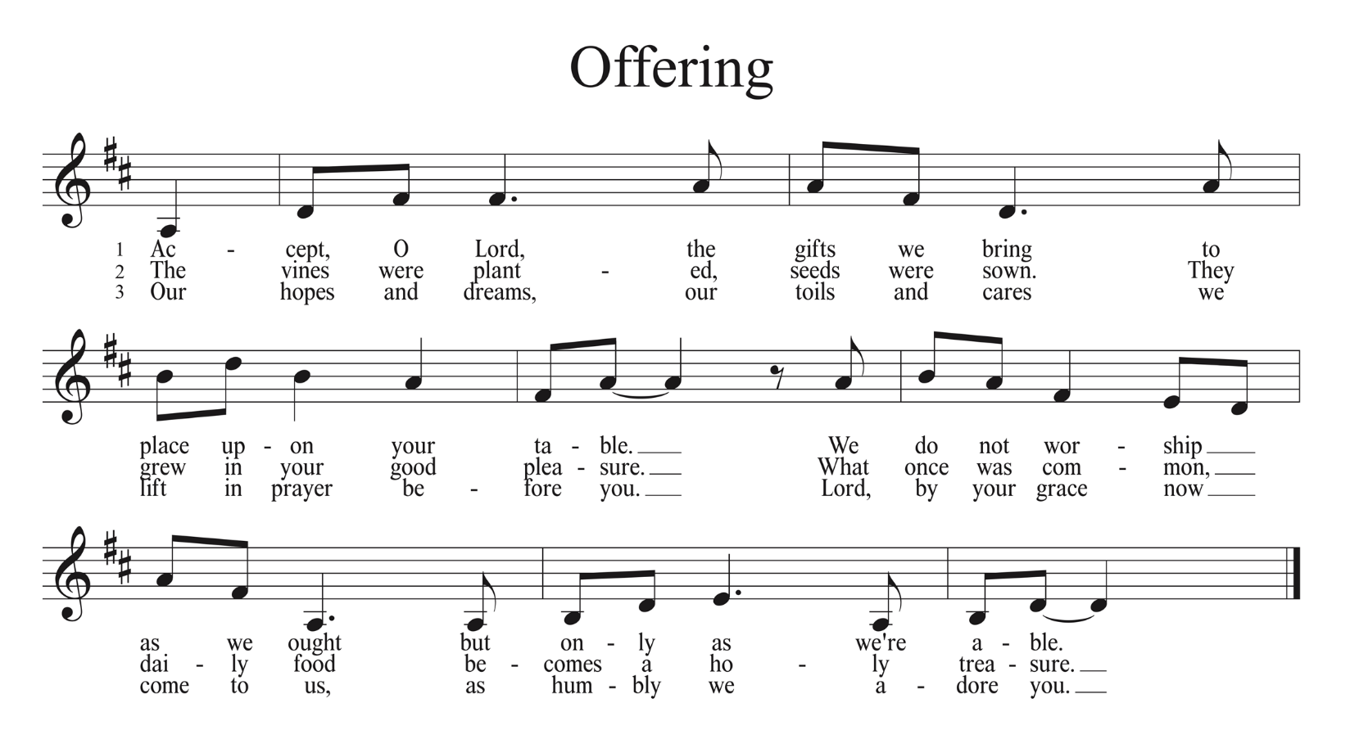

OFFERING PRAYER
A Let us pray…….God of goodness and growth,
C all creation is yours, and your faithfulness is sure. Word and water, wine and bread: these are signs of your abundant grace. Receive the gifts we bring, and nourish us to proclaim your abiding love in our communities and in the world, through Jesus Christ, our strength and our song. Amen.

THE GREAT THANKSGIVING

DIALOGUE AND PREFACE
P The Lord be with you.
C And also with you.
P Lift up your hearts.
C We lift them to the Lord.
P Let us give thanks to the Lord our God.
C It is right to give our thanks and praise.
P It is indeed right, our duty and our joy,…we praise your name and join their unending hymn:

HOLY, HOLY, HOLY
C Holy, holy, holy Lord, God of power and might,
heaven and earth are full of your glory.
Hosanna, hosanna, hosanna in the highest.
Blessed is he who comes in the name of the Lord.
Hosanna, hosanna, hosanna in the highest.

THANKSGIVING AT THE TABLE
P Blessed are you, O God, creator of heaven and earth.
You rescued your covenant people, led them on all their journeys,
and taught them by the prophets.
You so loved the world that you gave your only Son,
so that everyone who believes in him may not perish but may have eternal life.

In the night in which he was betrayed, our Lord Jesus took bread, and gave thanks;
broke it, and gave it to his disciples, saying:
Take and eat; this is my body, given for you.
Do this for the remembrance of me.

Again, after supper, he took the cup, gave thanks, and gave it for all to drink, saying:
This cup is the new covenant in my blood, shed for you and for all people
for the forgiveness of sin. Do this for the remembrance of me.

P As often as we eat this bread and drink this cup,
we proclaim the Lord’s death until he comes.
C Christ has died.
Christ is risen.
Christ will come again.

P Pour out your Holy Spirit in this meal,
and make us one in this community of faith
and with your people throughout the world.

Glory and praise to you, O God, Author of life, Word made flesh,
Power of the Most High, now and forever.
Amen.

LORD’S PRAYER
P Lord, remember us in your kingdom, and teach us to pray:
C Our Father, who art in heaven,
hallowed be thy name,
thy kingdom come,
thy will be done,
on earth as it is in heaven.
Give us this day our daily bread;
and forgive us our trespasses,
as we forgive those who trespass against us;
and lead us not into temptation,
but deliver us from evil.
For thine is the kingdom, and the power, and the glory,
forever and ever. Amen

INVITATION TO COMMUNION
P The gifts of God for the people of God. Take them in remembrance that Christ died for you, and feed on him in your hearts by faith, with thanksgiving.

DISTRIBUTION
All are welcome at God’s table, and we invite all to share in the sacrament of Communion, receiving the true body and blood of Christ. To receive communion, you may use prepackaged elements, or you may come to the altar to receive bread and wine (please pick up a small plastic cup on the way). Grape juice is also available. Those who do not wish to receive communion may come forward for a blessing. As the leader/assistants give the bread and wine, they say these words to each person:
The body of Christ, given for you.
The blood of Christ, shed for you.
The communicant may say: Amen

POST COMMUNION BLESSING
P The body and blood of our Lord Jesus Christ strengthen you and keep you in his grace.

POST COMMUNION PRAYER
A O giver of every good gift,
C You have fed us at your table that we might abide in your love and draw our life from you. Send us forth into the world to bear the fruits of the Spirit, that all creation might be filled with the life of the risen Christ, in whose name we pray. Amen.

SENDING SONG—Please see insert.

DISMISSAL AND BLESSING

P Go forth into the world, rejoicing in the power of the Holy Spirit!
C Thanks be to God.
P The blessing of Almighty God, Father, +Son and Holy Spirit, be with you this day and forever.
C Amen.

All liturgy and music from Sundaysandseasons.com. Copyright 2022 Augsburg Fortress. All rights reserved.

